**Дата**: 10.02.2025

**Клас**: 5-АБ

**Предмет**: англійська мова

**Тема:** Прогноз погоди на завтра.

**Мета:** формувати навички вживання лексичних одиниць по темі; удосконалювати навички читання, аудіювання й усного монологічного мовлення; розвивати пізнавальні інтереси учнів; виховувати інтерес до самостійного пошуку потрібної інформації, а також загальну культуру учнів.

**Вчитель**: Руда Д.В.

Хід уроку

1.Greeting

Good afternoon, guys! I’m pickled pink to see you. Are you ready to start our lesson? All set?

2. Повторення

Повторити Irregular verbs .

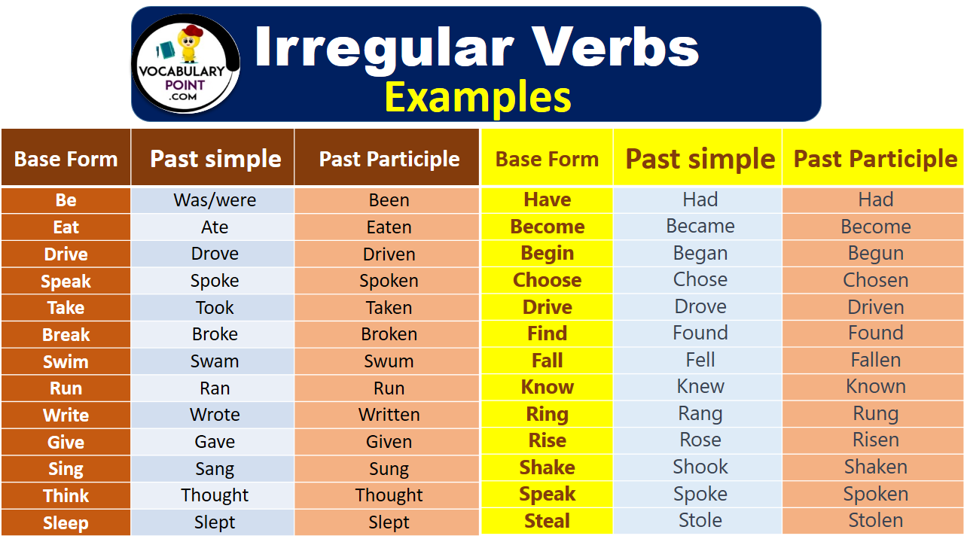

***Вивчити словник (бути готовим до слоникового диктанту) :***

*Careful-обережно (кеафул)*

*Slippery-слизько (сліпері)*

*To put on- одягати (пут он)*

*Overcast: covered with clouds; no sun is visible.- похмуро, сонця нема (овекаст)*

*"Under the weather": feeling ill or in low spirits. (e.g., "I'm feeling a bit under the weather today, so I'll stay home from work.")- мати погане самопочуття ( анде за везе)*

.

*Drizzle-мряка(дрізл)*

*Showers- a [short](https://dictionary.cambridge.org/dictionary/english/short" \o "short) [period](https://dictionary.cambridge.org/dictionary/english/period" \o "period) of [rain](https://dictionary.cambridge.org/dictionary/english/rain" \o "rain) or [snow](https://dictionary.cambridge.org/dictionary/english/snow" \o "snow)*

*Downpour- a lot of [rain](https://dictionary.cambridge.org/dictionary/english/rain" \o "rain) in a [short](https://dictionary.cambridge.org/dictionary/english/short" \o "short) [time](https://dictionary.cambridge.org/dictionary/english/time" \o "time) (дайн пор)*

*Flood-повінь(флад)*

*Hail-град(хейл)*

*Sleet-мокрий сніг(сліт)*

*Snowflake-сніжинка(сноуфлейк)*

*Blizzard-хуртелиця (блізард)*

*Mild: moderate in temperature; neither hot nor cold- помірний, м’який (майлд)*

*"Every cloud has a silver lining": every bad situation has some positive aspect to it. (e.g., "I lost my job, but I found a better one soon after. Every cloud has a silver lining.")- нема лиха без добра( ідіома)*

*To expect-очікувати(експект)*

*To report-повідомити(ріпот)*

*Chilly-прохолодний(чілі)*

*To get cold-холоднішати*

*raining cats and dogs-сильно дощити (ідіома)*

*They cancelled the football game because it was raining cats and dogs.*

*puddle-калюжа (падл)*

*precipitation-опади (прісіпітейшн)*

*partly cloudy- мінлива хмарність (патлі клауді)*

*to be below freezing- бути нижче нуля*

*bitterly cold- дуже холодно*

*a blanket of snow-сніговий покрив*

*boiling hot- дуже спекотно*

*changeable-мінлива*

*a change in the weather- зміна погоди*

*clear blue skies- чисте блакитне небо, без хмар*

*to clear up-прояснятися*

*to come out (the sun)- виходить сонце із-за хмар*

3. Wаrm up / Listening

Уважно слухати аудіо трек і дати відповідь на питання вчителя <https://www.youtube.com/watch?v=_0S8VpU3bTY> .

4. Speaking

What kind of climate do you prefer when choosing a place to go on vacation?

What is the best season to get married?

Can you think of other activities in which one season may be better than another?

What are the seasons?

What is the hottest season?

What is the coldest season?

In your opinion, which season is the most beautiful?

Which season is the most comfortable for you?

Why do you think spring (or another season) is the most beautiful season?

Have you ever been stranded in a snowstorm? What did you do?

Do you think weather affects the way people feel?

How can extreme weather conditions affect the economy and social life in countries?

Do you think weather patterns are changing?

If so, what do you think is causing these changes?

What are the different kinds of weather?

What is the weather like in your country for each season?

What some of the different kinds of weather?

What is the weather like in your country for each season?

How does weather affect your attitude?

How does weather affect your lifestyle?

What is the relationship between weather and natural disasters?

How to you depend on the weather reports on TV?

How do television stations secure weather reports?

Why is it important to know future weather conditions in advanced?

When would knowing tomorrow's weather change you plans?

Have you ever checked the weather for your city on the Internet?

What time of year is the best weather where you live?

5. Writing

Виконати вправу подану нижче.

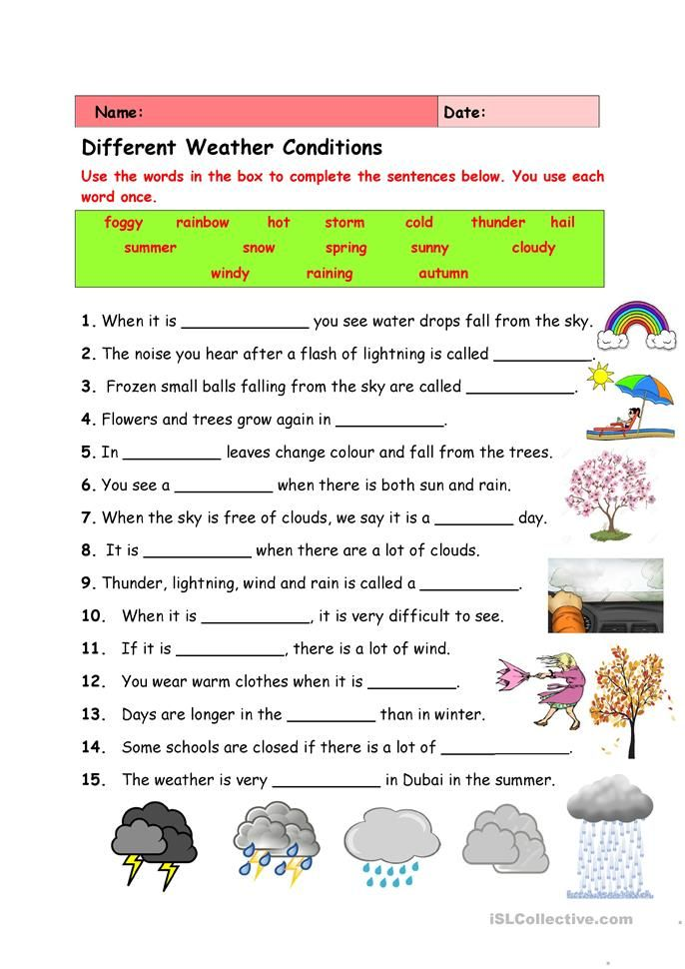

6. Homework

1. Уявити себе метеорологом та написати прогноз погоди на 11.02.25 .

2. Повторити слова в словнику.